Fitness Band Bicep Curls

[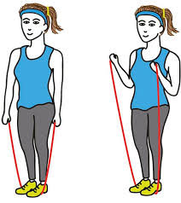](http://www.google.com/url?sa=i&rct=j&q=&esrc=s&source=images&cd=&cad=rja&uact=8&ved=0ahUKEwiJwsPC1NHTAhUBvBoKHeDtA00QjRwIBw&url=http://www.expertrain.com/blog/fitness/resistance-band-exercises-that-can-be-done-anywhere.htm&psig=AFQjCNHZm17HzLGaFUSc0obj8WJnGLso5g&ust=1493829982716222)

Fitness Band Tricep Curls

[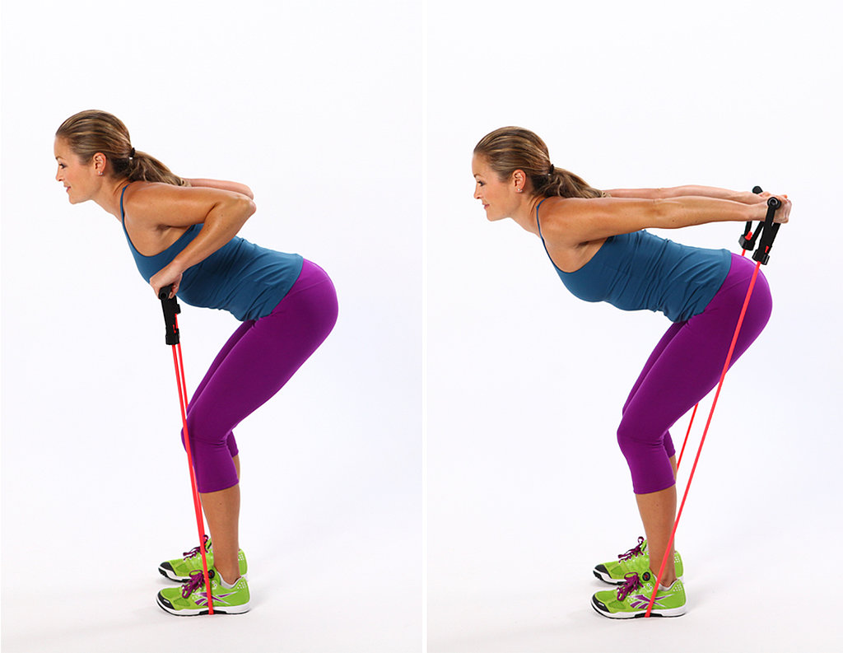](https://www.google.com/url?sa=i&rct=j&q=&esrc=s&source=images&cd=&cad=rja&uact=8&ved=0ahUKEwjWps7n1NHTAhXDOxoKHY8-AkYQjRwIBw&url=https://www.pinterest.com/kahansen23/exercise/&psig=AFQjCNGL_JB-GIweWGbhg1x945ICFUpQMA&ust=1493830027792659)

Resistance Bands

[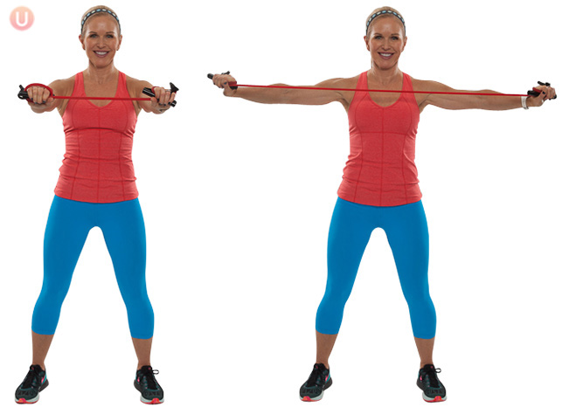](http://www.google.com/url?sa=i&rct=j&q=&esrc=s&source=images&cd=&cad=rja&uact=8&ved=0ahUKEwjwxt2C1dHTAhWB7hoKHUXlAkYQjRwIBw&url=http://gethealthyu.com/7-best-resistance-band-moves-to-tone-the-whole-body/&psig=AFQjCNH0Z1hxkhonSqsliL7RVCaHfH8KxQ&ust=1493830103719731)

Ball Sit Ups

[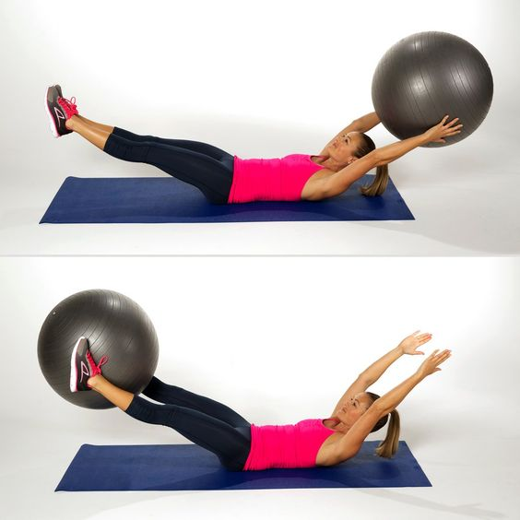](https://www.google.com/url?sa=i&rct=j&q=&esrc=s&source=images&cd=&cad=rja&uact=8&ved=0ahUKEwjekufBz9HTAhXJhRoKHe8BCUQQjRwIBw&url=https://www.pinterest.com/pin/287245282464682345/&psig=AFQjCNFKkrBACJ1AYXUKLvd45vSqsu7kRw&ust=1493828622577503)

Push Ups

[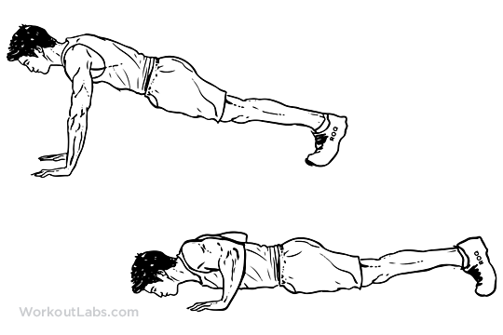](http://www.google.com/url?sa=i&rct=j&q=&esrc=s&source=images&cd=&cad=rja&uact=8&ved=0ahUKEwi65euDjazKAhVGPz4KHTCFBtIQjRwIBw&url=http://workoutlabs.com/exercise-guide/pushup/&psig=AFQjCNFAVv5SWWvXFZWyYn--xRaJUevyzg&ust=1452957062874095)

Or

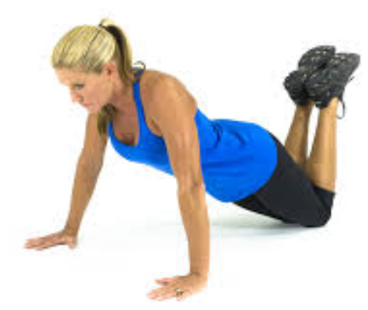

Jump Rope

[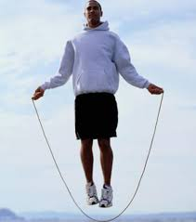](http://www.google.com/url?sa=i&rct=j&q=&esrc=s&source=images&cd=&cad=rja&uact=8&ved=0ahUKEwiL2cK5jazKAhVFFj4KHVwEA3oQjRwIBw&url=http://www.mensfitness.com/training/cardio/jump-rope-cardio&psig=AFQjCNEQzJfR4oK9PhkG0-s_BRnfdIwWeQ&ust=1452957156590829)

4

Wall Sit

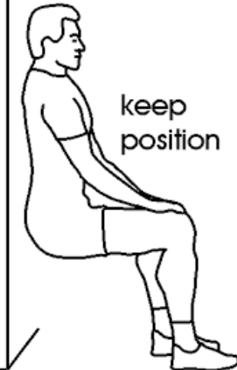

Tricep Dips

[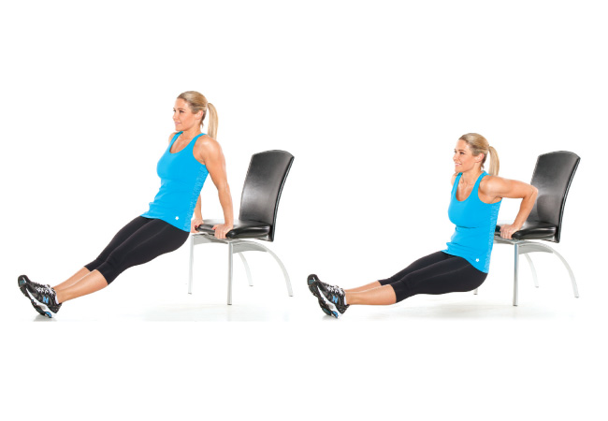](https://www.google.com/url?sa=i&rct=j&q=&esrc=s&source=images&cd=&cad=rja&uact=8&ved=0ahUKEwj_uYfHpazKAhWIej4KHRMFCkMQjRwIBw&url=https://www.reddit.com/r/bodyweightfitness/comments/2hab2g/why_cant_i_do_dips/&psig=AFQjCNHD1X37Yzn6sL3dURGGkGL0Xzbsbw&ust=1452963640634849)Or [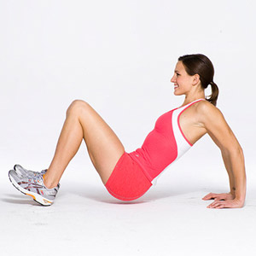](http://www.google.com/url?sa=i&rct=j&q=&esrc=s&source=images&cd=&cad=rja&uact=8&ved=&url=http://destinationfittraining.ca/the-wake-up-workout-in-bed/&psig=AFQjCNELbHE2zO6YECyqbH8vcOQfB9BLHg&ust=1452956713622024)

Crunches

[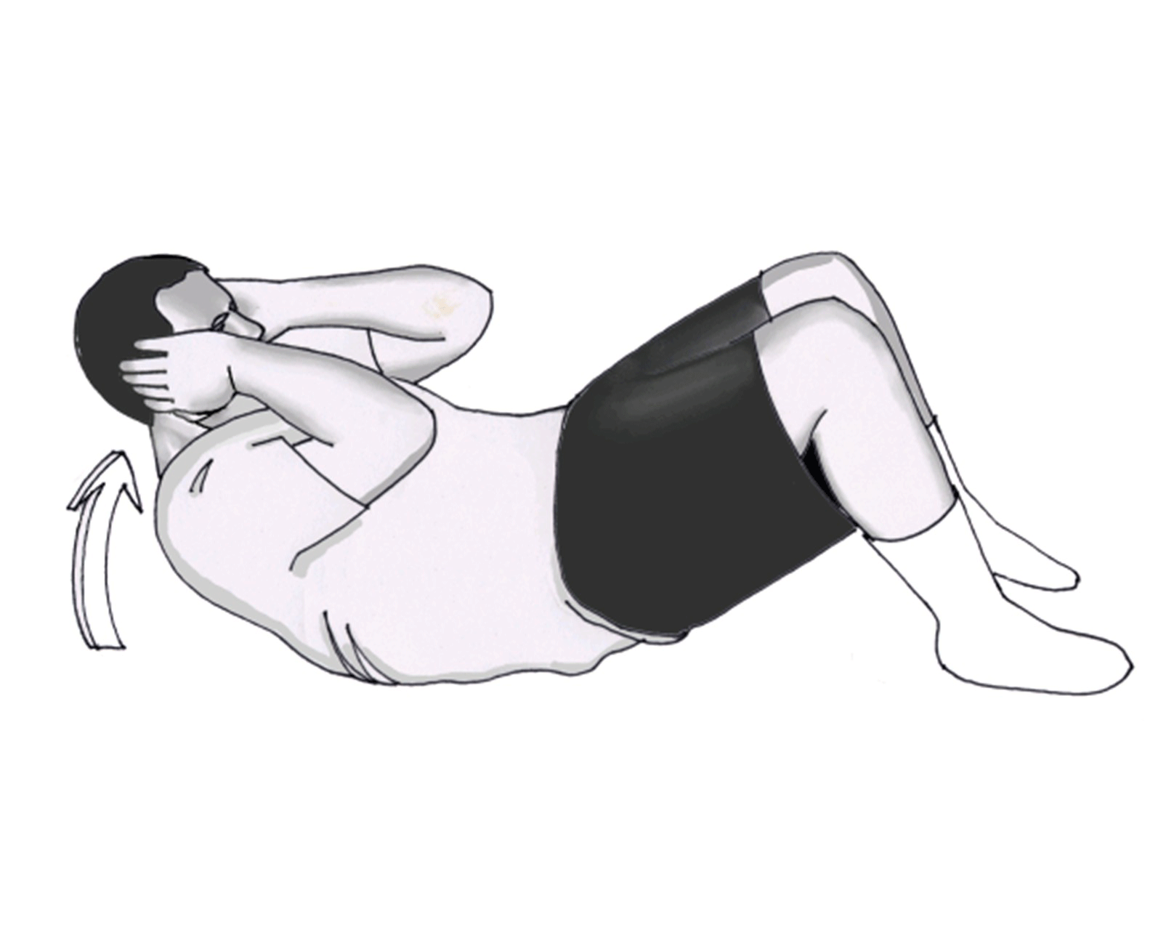](http://www.google.com/url?sa=i&rct=j&q=&esrc=s&source=images&cd=&cad=rja&uact=8&ved=0ahUKEwi_tMW2jKzKAhVMdD4KHWn6BPMQjRwIBw&url=http://www.lifelongexercise.com/core_illustration_1.asp&psig=AFQjCNFQ-_p0TyZcotP0AhuGC6FTVwtSOw&ust=1452956890631081)

Bicycle

[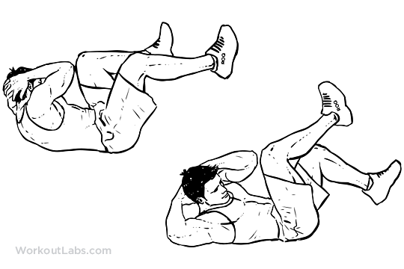](http://www.google.com/url?sa=i&rct=j&q=&esrc=s&source=images&cd=&cad=rja&uact=8&ved=0ahUKEwie09XBjKzKAhVCPj4KHYtNCmgQjRwIBw&url=http://workoutlabs.com/exercise-guide/bicycle-crunches-air-bikes/&psig=AFQjCNFQ-_p0TyZcotP0AhuGC6FTVwtSOw&ust=1452956890631081)

High Knees

[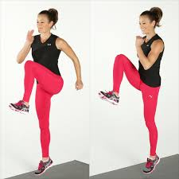](https://www.google.com/imgres?imgurl=http://media3.popsugar-assets.com/files/2014/01/18/687/n/1922729/75796db2c6bce686_highknees.jpg.xxxlarge/i/Plyometrics-High-Knee-Skips.jpg&imgrefurl=http://www.popsugar.com/fitness/photo-gallery/34376556/image/34376688/Plyometrics-High-Knee-Skips&h=1024&w=1024&tbnid=M0ZLI21_dLRgrM:&docid=6IeNwwgkhNHosM&ei=PQqZVsulM4r5-AGY2bCYCA&tbm=isch&ved=0ahUKEwiLuJiki6zKAhWKPD4KHZgsDIMQMwgoKAwwDA)

Box Jumps

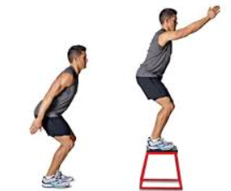

Agility Hoop

[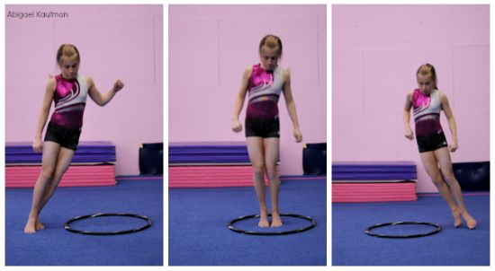](http://www.google.com/url?sa=i&rct=j&q=&esrc=s&source=images&cd=&cad=rja&uact=8&ved=0ahUKEwia8vCQiazKAhXCPD4KHZLQC5QQjRwIBw&url=http://gymnasticscoaching.com/new/2014/07/quick-tip-jumping/&bvm=bv.112064104,d.cWw&psig=AFQjCNEHRq1na571d8DbBo3KwxpFHJoA5g&ust=1452956014051234)

Agility Ladder Hoops

[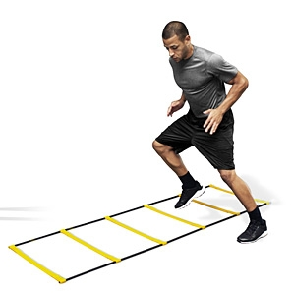](http://www.google.com/url?sa=i&rct=j&q=&esrc=s&source=images&cd=&cad=rja&uact=8&ved=0ahUKEwjaj5WIiqzKAhVLaT4KHQD_BuoQjRwIBw&url=http://bobbydattero.com/archives/1656&bvm=bv.112064104,d.cWw&psig=AFQjCNFaD78g5WvcxA49OZUSRU9FALEtoA&ust=1452956274127391)

[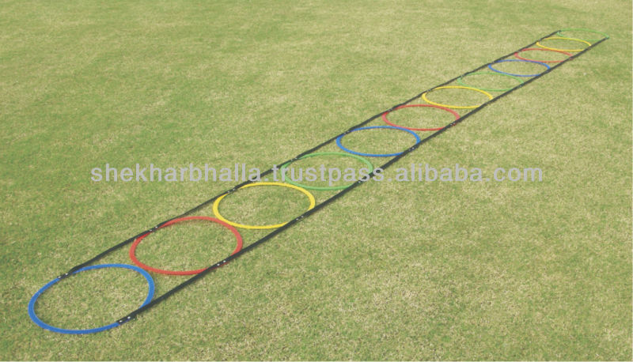](http://www.google.com/url?sa=i&rct=j&q=&esrc=s&source=images&cd=&cad=rja&uact=8&ved=0ahUKEwjotdakiqzKAhVFHT4KHalaD1AQjRwIBw&url=http://www.alibaba.com/product-detail/Hoops-Agility-Ladder-Multi-Colour_230633855.html&bvm=bv.112064104,d.cWw&psig=AFQjCNHfEg1A_f_l-8ZQVP8HvamLr8BFnA&ust=1452956296532482)

Step Ups

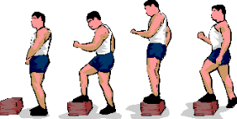

Hamstring Stretch

[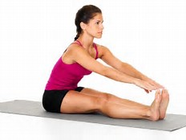](http://www.bing.com/images/search?view=detailV2&ccid=G9zACFGU&id=518CD0413DBF56C075F5F68507B6210F99330439&thid=OIP.G9zACFGUyVWqDYNE4mwU9gEsDh&q=hamstring+stretch&simid=607995344270197079&selectedIndex=2)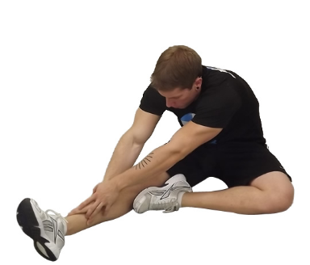

Stability Ball

Push Ups

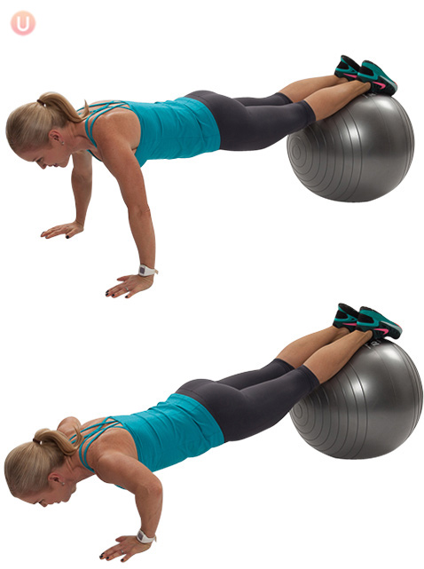or 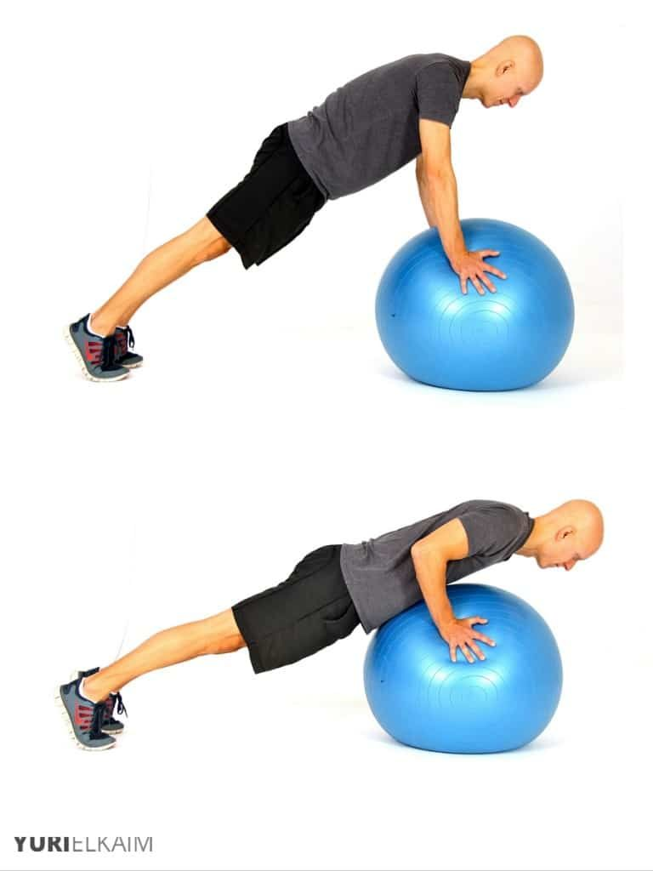

Stability Ball Crunches

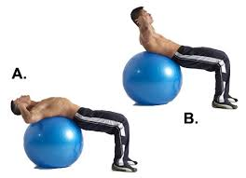

Yoga

Overhead Press

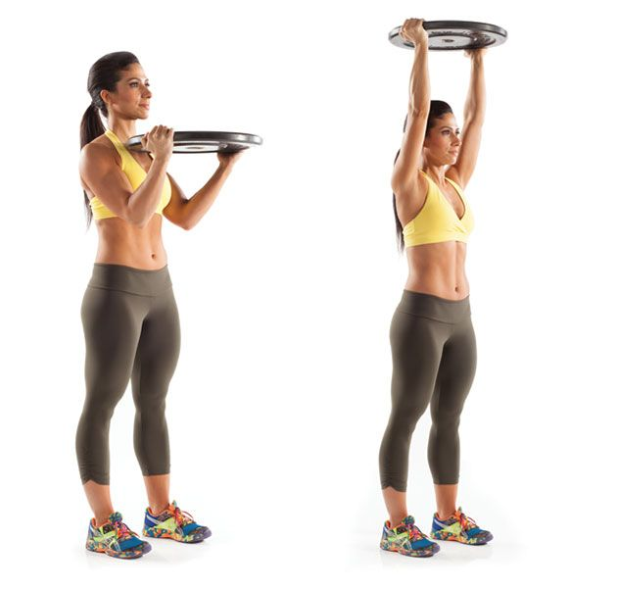

Upper Body

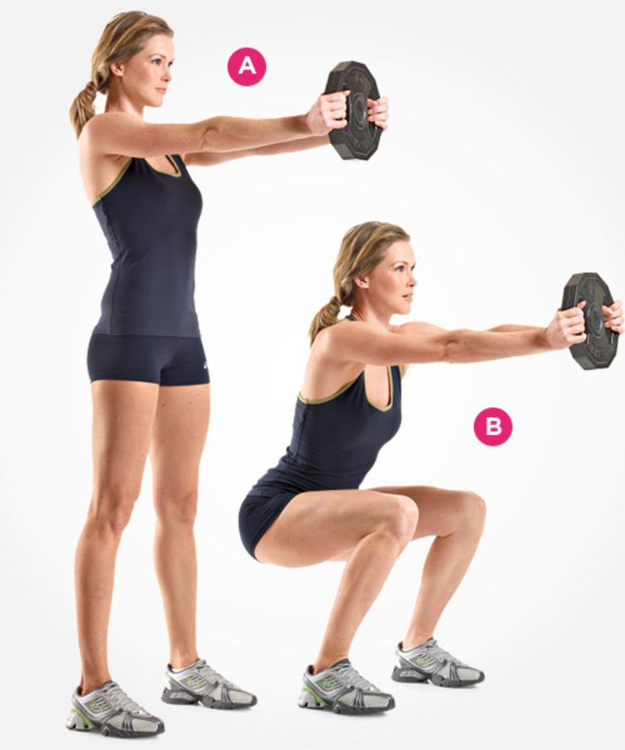

Ab Wheel

[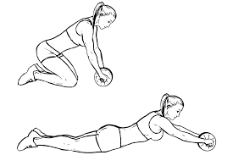](https://www.google.com/url?sa=i&rct=j&q=&esrc=s&source=images&cd=&cad=rja&uact=8&ved=0ahUKEwjw66WnpuPTAhVC1oMKHYLLC3MQjRwIBw&url=https://workoutlabs.com/fit/wkt/q5uP9Mj/&psig=AFQjCNFJS2HCiN9O4BXyc0Kvugwu8MPtsw&ust=1494436018887936)

Battle Rope with 5 Squats Take Turns

[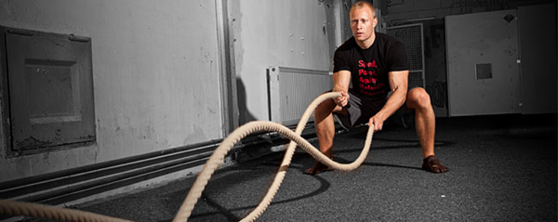](http://www.google.com/url?sa=i&rct=j&q=&esrc=s&source=images&cd=&cad=rja&uact=8&ved=0ahUKEwiE4ue_muPTAhUkxoMKHTcRBxkQjRwIBw&url=http://www.garage-gyms.com/battle-rope-workouts/&psig=AFQjCNEQRSlcmsVmLUTMsbViNgSrmoDP7Q&ust=1494432886887392)

Upper Body Table Pull

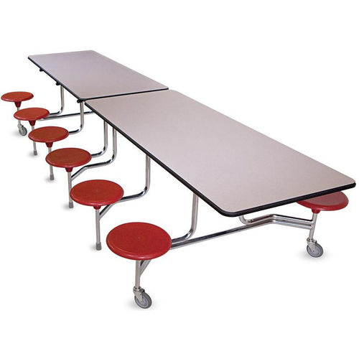

Can’t Use your Feet

Squats

Tire Flip