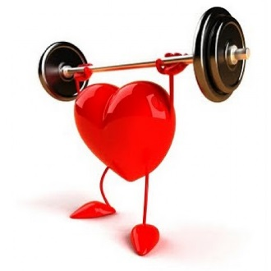
Happy Heart Month
Physical Education Standard 3: Resource Management
Here is a gift for your heart!!! 12 exercises you can do at home with no equipment! Perform each exercise for 1 whole minute and take 20 seconds rest in between. Check out our website at www.GranbyPE.Weebly.com and click the fitness unit tab
to see more at home exercises. Students should know how to do a proper warm up and proper stretching techniques from class.
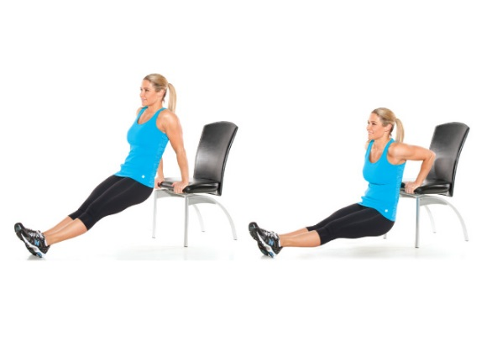
Push Ups Wall Sit Tricep Dips Squat Thrust
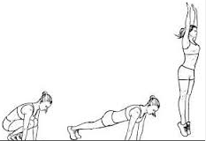
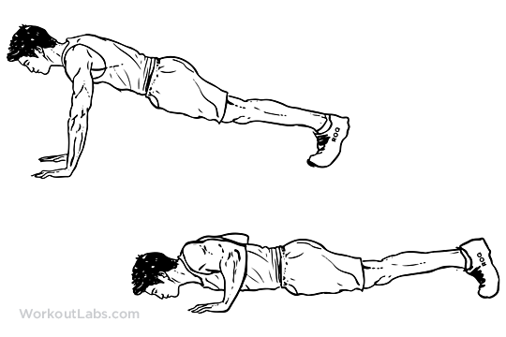
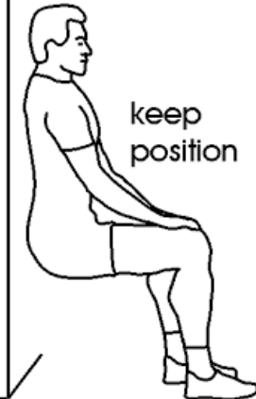
Bicycle Abs High Knees Box/Stair Jumps Bench/Counch
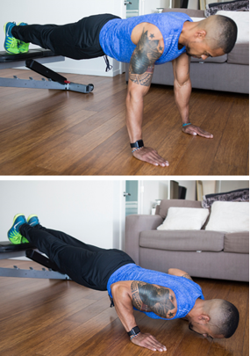
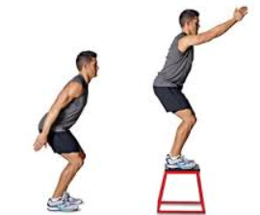
Plank or Push Ups
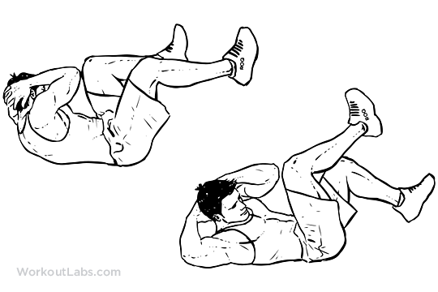

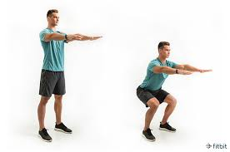
Squats Jumping Jacks Sit Ups

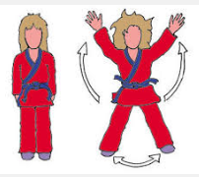
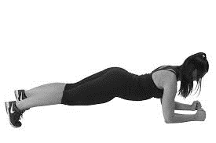
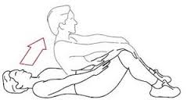
Plank

Love,
Mrs. Maselli, Mr. Popper & Mr. Wallace

