5th and 6th Grade Cross Country Meet
Thursday, October 4, 2018
3:00 at Granby Elementary School
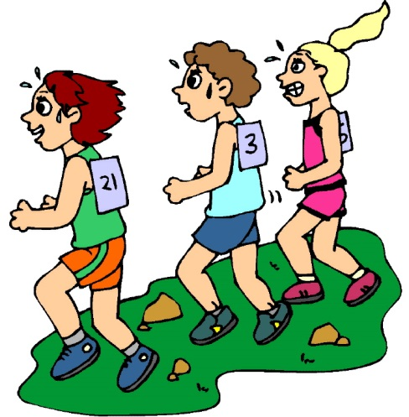
Interested student athletes should sign and return this permission slip to their physical education teacher by Thursday, October 4. The race distance is between ¾ and 1 mile.
Transportation home after the meet is up to the family.
We will end at approximately 3:30.
Return Permission slip by Tuesday, October 2.

__________________________Grade
__________________________Classroom Teacher

__________________________(Print Student’s Name) has my permission to participate in the cross country meet.
Bring water and of course your running sneakers.
I will arrange transportation from Granby home at 3:30.
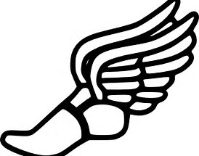
___________________________ _________________________
(Parent/Guardian Signature) (Phone Number)

