5TH & 6TH GRADE
WRESTLING TOURNAMENT

Tuesday, October 30, 2018
2:30 at Fulton War Memorial

Interested students should sign and return permission slips to their physical education teacher by Monday, October 29.

Transportation will be provided at 1:55 from the elementary schools to the War Memorial. Transportation from the War Memorial home, after the tournament (approx. 4:00) is the responsibility of the family.

- - - - - - - - - - - - - - - - - - - - - - - - - - - - - - - - - - - - - - - - - - - - -

___________________ (Grade)

___________________ (Teachers Name)

___________________ (Students Name) has my permission to participate in the 5/6 wrestling tournament.

I will arrange transportation from the Fulton War Memorial home at 4:00.

____________________________
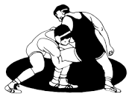
(Print Parent Name)

____________________________
(Phone Number)

