Gas Station

When to Fill Up:
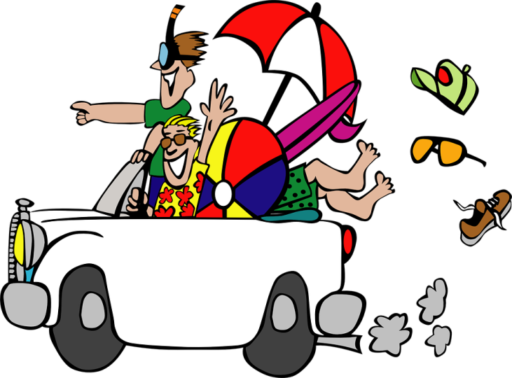
5 Laps Done Working
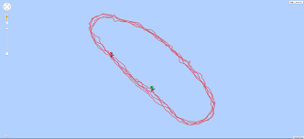

Fill your tank for $2.00
Vacation Spot
Climb the Apalachian Mountains

for $1.00 each climb
Police
Traffic Control/Safety
- Everyone on the road is in a car
- Reckless driver goes to jail if crash
City Peace
- Robbery- anyone who does not pay goes to jail
- Participation- go to jail if not participating
- Record Name check ticket number

Pay the officer $1.00 and send them to jail
Jail
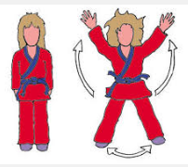
Complete:
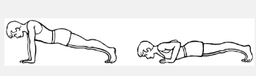
10 jumping jacks
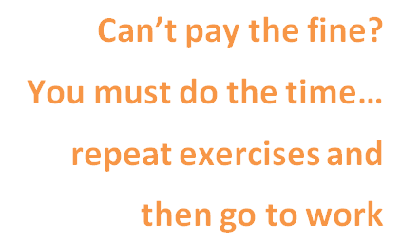
10 push ups
10 mountain climbers
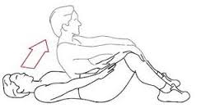
10 sit ups
Pay fine $2.00
College
No money?
No work?

Educate yourself so employers will want to hire you!
Hit play on video and learn something new.
Watch for job opportunities to come available.
Vacation Spot
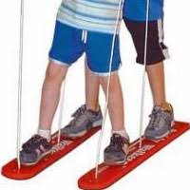
Ski with a Buddy

Pay $1.00 (1 minute)
Vacation Spot
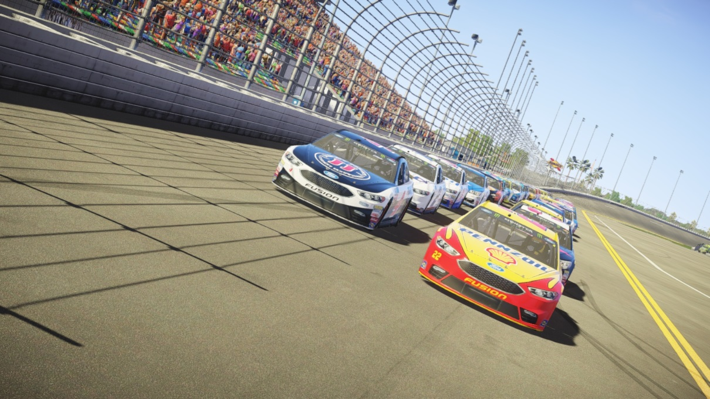
NASCAR Race

Race a Buddy and Pay $1.00 each person each race
Vacation Spot
Amazon Rain Forest

Rope Climb for $1.00 (1 Turn)
Vacation Spot
Bowling
Set pins back
up or call police

Bowl for $1.00 (2 turns)
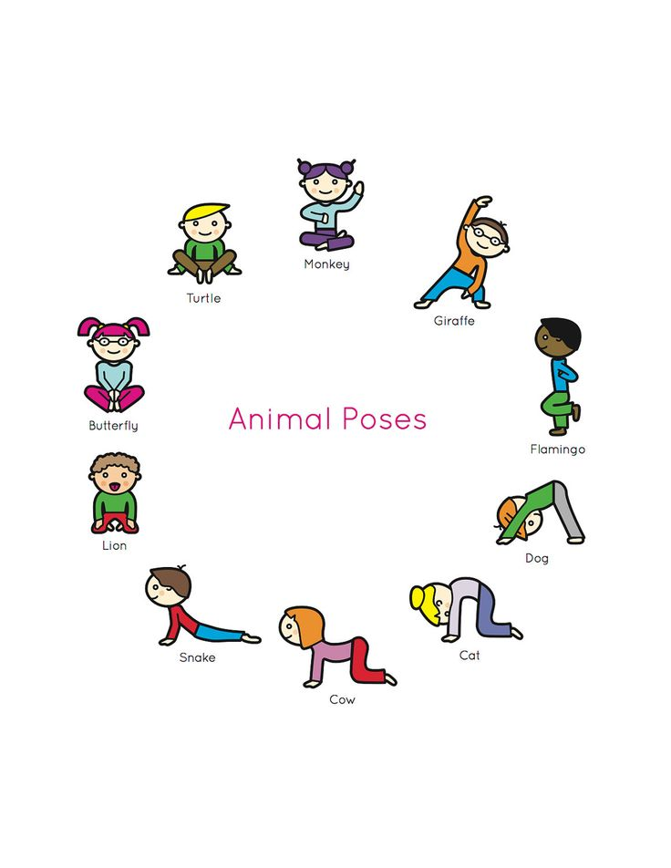
Vacation Spot
Spa
Yoga Poses

Pay $1.00 for 3 Minutes
Call Policemen if a guest is not working out
Rules:
Teacher/Banker- give loan to kids to start 5 dollars each (need 500 dollars) Set up the city send 5 kids to each “station” to start.
Gas Station First thing you have to do is get gas. Fill up for 2.00. Gas is expensive. Can’t go anywhere without a car. Driving around is fine but 5 laps around cost money burning fuel. Need to fill up
Employees/Workers- Policemen and gas station jobs must be filled first and then can choose any other position. do not let anyone on unless they pay. Workers salary cap is 10 dollars. After 10 dollars you have to leave work. 1st thing you do is fill up on gas. Issue with a guest. Call police
Policemen: watch out for violations. Someone comes to you because they were in a crash or they witness a violation. “Ticket” that person. First offense see policemen pay 1.00 then go to jail pay 1.00 and complete exercises. If you can’t pay the fine then you must do the time. Repeat exercises and get a job. You can’t live in a city without law enforcement. Before choosing a job you must make sure policemen is full
No vacancy- only 8 kids per vacation spot
No work available? Drive to college and flip scooter over. Educate yourself so you are valuable to employees and they will want to hire you.
No one working then its closed
Ticket
Name | Ticket 1 | Ticket 2 | Ticket 3

Bowling
College
Spa
Police
And Jail
Skiing
Gas Station
Road
Amazon Rain Forest
Rock
Wall
Nascar

